Debt
- Lending and borrowing as buying and selling debt.
- APR’s versus effective rates.
- Home loans:
  - Fully amortising loans.
  - Interest only loans.
- Bond pricing exactly one period before the next coupon.
- Bond pricing between coupons.
- Short term wholesale (money market) debt and overview.
- Yield curves and the term structure on interest rates.
Borrowing: Synonyms
Borrowers receive money at the start. Borrowing is equivalent to selling a debt contract.
To remember that a borrower sells debt, just think about how a borrower receives cash at the start. If you’re in a shop and you receive cash, that’s because you’re the seller, not the buying customer.
If a lady sells debt to a man, she receives cash now in return for selling her promise to pay him back the principal and interest later. She sells the debt contract, she is the borrower.

Borrowing is also known as:
- Selling debt (receiving money at the start)
- Having a debt liability
- Issuing debt (issuing the debt contract at the start)
- Being short debt (shorting is a synonym of selling)
- Owing money (a borrower ‘owes’ money)
- Being in debt
- Being a debtor. Or less commonly, a creditee.
- Writing debt (since you write the contractual promise to pay back principal and interest and give the paper contract to the lender)

Lending: Synonyms
Lenders give money at the start. Lending is equivalent to buying a debt contract.
To remember that a lender buys debt, just think about how a lender gives cash at the start. If you’re in a shop and you pay cash, that’s because you’re the buying customer, not the selling shop keeper.
If a man buys debt from a lady, he pays cash now to buy her promise to pay him back the principal and interest later. He buys the debt contract, he is the lender.

Lending is also known as:
- Buying debt (giving money at the start)
- Having a debt asset or owning a debt asset
- Investing in debt
- Being long debt (longing is a synonym of buying, shorting is selling)
- Being a creditor. Or less commonly, a debtee.
- Being owed money. Note that this is not the past tense of owe. “He is owed money” means the man is a lender. “She owes money” means the lady is a borrower.

Questions: Debt Terminology
http://www.fightfinance.com/?q=128,129,130,374,234,372,373,

Annualised Percentage Rates (APR's)
Most interest rates are quoted as Annualised Percentage Rates (APR's). This is both by convention and in some countries by law. This is true for credit card rates, mortgage rates, bond yields, and many others.
The compounding period of an APR is not always explicitly stated. However, it can usually be assumed that the compounding frequency of an APR is the same as the payment frequency.
For example, a credit card might advertise an interest rate of 24% pa. This must be an APR since all advertised rates have to be APR's by law. Because credit cards are always paid off monthly, the compounding frequency is per month. Therefore the interest rate is 24% pa given as an APR compounding monthly.
While APR’s are the rate that you see quoted and advertised, unfortunately they cannot be used to find present or future values of cash flows. You must convert the APR to an effective rate before doing financial mathematics.

Confusion: APR's are sometimes called nominal rates. Unfortunately, nominal has another meaning related to inflation (nominal versus real returns). We will avoid calling APR's nominal rates in these notes.

Effective Rates
Effective rates compound only once over their time period, and the time period can be of any length, not necessarily annual.
Effective rates can be used to discount cash flows.
APR's cannot be used to discount cash flows, they must be converted to effective rates first.

Note that all of the calculation examples up to here have assumed that the interest rate given is an effective rate.
Calculation Example: Present Values and Effective Rates
Question: What is the present value of receiving $100 in one year when the effective monthly rate is 1%?
Answer: Since the effective interest rate is per month, the time period must also be in months, so:
$$V_{o}=\frac{C_{t}}{{\left(1+r\right)}^{t}}$$
$$=\frac{100}{{\left(1+0.01\right)}^{12}}$$
$$=88.7449$$
APR's and Effective Rates
- An APR compounding monthly is equal to 12 multiplied by the effective monthly rate.
$$r_{APR comp monthly}=r_{eff monthly}×12$$

- An APR compounding semi-annually is equal to 2 multiplied by the effective 6 month rate.
$$r_{APR comp per 6mths}=r_{eff 6mth}×2$$

- An APR compounding daily is equal to 365 multiplied by the effective daily rate.
$$r_{APR comp daily}=r_{eff daily}×365$$
Example: Future Values with APR's
Question: How much will your credit card debt be in 1 year if it's $1,000 now and the interest rate is 24% pa?
Wrong Answer: $V_{t}=C_{0}{\left(1+r\right)}^{t}=1000{\left(1+0.24\right)}^{1}=1,240$
Answer: Since credit cards are paid off per month and rates are by default given as APR’s, the 24% must be an APR compounding monthly. Therefore the effective monthly rate will be the APR divided by 12.
$$r_{eff monthly}=\frac{r_{APR comp monthly}}{12}=\frac{0.24}{12}=0.02$$
$$V_{12mths}=C_{0}{\left(1+r_{eff monthly}\right)}^{t_{months}}$$
$$=1000{\left(1+0.02\right)}^{12}=1,268.2418$$
Converting Effective Rates To Different Time Periods
Compounding the rate higher (up to a longer time period):
$$r_{eff annual}={\left(1+r_{eff monthly}\right)}^{12}-1$$
$$r_{eff semi-annual}={\left(1+r_{eff monthly}\right)}^{6}-1$$
$$r_{eff quarterly}={\left(1+r_{eff monthly}\right)}^{3}-1$$
Compounding the rate lower (down to a shorter time period):
$$r_{eff monthly}={\left(1+r_{eff annual}\right)}^{\frac{1}{12}}-1$$
$$r_{eff daily}={\left(1+r_{eff annual}\right)}^{\frac{1}{365}}-1$$
Calculation Example: Converting Effective Rates
Question: A stock was bought for $10 and sold for $15 after 7 months. No dividends were paid. What was the effective annual rate of return?
Answer:
First we find the return over 7 months. This will be the effective 7 month rate of return. Note that the time period is in 7-month blocks:
$$V_{0}=\frac{V_{t}}{{\left(1+r\right)}^{t}}$$
$$V_{0}=\frac{V_{7months}}{{\left(1+r_{eff 7month}\right)}^{1_{seven month period}}}$$
$$10=\frac{15}{{\left(1+r_{eff 7month}\right)}^{1}}$$
$${\left(1+r_{eff 7month}\right)}^{1}=\frac{15}{10}$$
$r_{eff 7month}=\frac{15}{10}-1=0.5=50\%$, which is the effective 7 month rate.
Now we need to convert the effective 7 month rate to an effective annual rate (EAR). This can be done by ‘compounding up’ by 12/7 in one step:
$$r_{eff annual}={\left(1+r_{eff 7mth}\right)}^{\frac{12}{7}}-1$$
$$={\left(1+0.5\right)}^{12/7}-1=1.0039=100.39\%$$
Or it can be broken down into steps:
- Compounding the 7-month rate down to a monthly rate:
$$r_{eff monthly}={\left(1+r_{eff 7mth}\right)}^{1/7}-1$$
$$={\left(1+0.5\right)}^{1/7}-1=0.059634=5.9634\%$$
- Then compound the monthly rate up to a 12-month (annual) rate:
$$r_{eff annual}={\left(1+r_{eff, monthly}\right)}^{12}-1$$
$$={\left(1+0.059634\right)}^{12}-1=1.0039=100.39\%$$

Calculation Example: Converting APR's to Effective Rates
Question: You owe a lot of money on your credit card. Your credit card charges you 9.8% pa, given as an APR compounding per month.
You have the cash to pay it off, but your friend wants to borrow money from you and offers to pay you an interest rate of 10% pa given as an effective annual rate. Assume that your friend will definitely pay you back (no credit risk).
Should you use your cash to pay off your credit card or lend it to your friend?
Answer: The loan’s 10% effective annual rate can’t be immediately compared to the credit card’s 9.8% APR compounding per month.
Method 1: Convert the credit card's 9.8% APR compounding per month to an effective annual rate:
$$r_{eff monthly}=\frac{r_{APR comp monthly}}{12}=\frac{0.098}{12}=0.0081667$$
$$r_{eff annual}={\left(1+r_{eff monthly}\right)}^{12}-1$$
$$={\left(1+0.0081667\right)}^{12}-1=0.1025=10.25\%$$
So the credit card's 9.8% APR compounding per month converts to an effective annual rate of 10.25%. This is more than the loan's 10% effective annual rate.
You should pay off your credit card which costs 10.25% rather than lend to your friend which only earns 10%, where both rates are effective annual rates.
Method 2: Convert the loan’s 10% effective annual rate to an APR compounding per month:
$$r_{eff monthly}={\left(1+r_{eff annual}\right)}^{1/12}-1$$
$$={\left(1+0.1\right)}^{1/12}-1=0.00797414043$$
$$r_{APR comp monthly}=r_{eff monthly}×12$$
$$=0.00797414043×12$$
$$=0.09568968514=9.568968514\% pa$$
So the 10% effective annual rate that you can lend at converts to a 9.569% APR compounding per month. This is less than your 9.8% pa cost of funds using your credit card, where both are APR’s compounding monthly, so don’t lend to your friend.
Calculation Examples
Question: Assume 30 days per month and 360 days per year. Convert a 9.8% APR compounding per month into the following:
$$r_{eff 6month}={\left(1+\frac{0.098}{12}\right)}^{6}-1=0.050011377 per 6 months$$
$$r_{APR comp 6months}=\left({\left(1+\frac{0.098}{12}\right)}^{6}-1\right)×2=0.100022754 pa$$
$$r_{eff daily}={\left(1+\frac{0.098}{12}\right)}^{\frac{1}{30}}-1=0.000271153 per day$$
$$r_{APR comp daily}=\left({\left(1+\frac{0.098}{12}\right)}^{\frac{1}{30}}-1\right)×360=0.097615231 pa$$
Calculation Examples
Question: Assume 30 days per month and 360 days per year. Convert a 10% effective annual rate ($r_{eff annual}$) into the following:
$$r_{eff 6month}={\left(1+0.1\right)}^{6/12}-1=0.048808848 per 6 months$$
$$r_{APR comp 6months}=\left({\left(1+0.1\right)}^{6/12}-1\right)×2=0.097617696 pa$$
$$r_{eff daily}={\left(1+0.1\right)}^{1/360}-1=0.000264786 per day$$
$$r_{APR comp daily}=\left({\left(1+0.1\right)}^{1/360}-1\right)×360=0.095322798 pa$$
$$r_{eff 2 year}={\left(1+0.1\right)}^{2}-1=0.21 per 2 years$$
$$r_{eff 1 second}={\left(1+0.1\right)}^{1/(12×30×24×60×60)}-1=0.000000003064/s$$
$$r_{APR comp second}=r_{eff 1 second}×12×30×24×60×60 =0.0953101823 pa≈\ln\left(1+0.1\right)=r_{continuously compounded pa}$$
Questions: APR's and Effective Rates
http://www.fightfinance.com/?q=290,330,16,26,131,49,64,265,

Fully Amortising Loans
Most home loans are fully amortising or ‘Principal and Interest’ (P&I) loans.
When a fully amortising home loan borrower makes their last payment, the loan is fully paid off.
We can value fully amortising home loans using the annuity formula assuming that the interest rate r is expected to be constant.
$$V_{0 fully amortising}=\frac{C_{1}}{r}\left(1-\frac{1}{{\left(1+r\right)}^{T}}\right)$$

Example: Fully Amortising Loans
Question: Mortgage rates are currently 6% and are not expected to change.
You can afford to pay $2,000 a month on a mortgage loan.
The mortgage term is 30 years (matures in 30 years).
What is the most that you can borrow using a fully amortising mortgage loan?
Answer: Since the mortgage is fully amortising, at the end of the loan's maturity the whole loan will be paid off.
The bank will lend you the present value of your monthly payments for the next 30 years. This can be calculated using the annuity formula.
The $2,000 payments are monthly, therefore the interest rate and time periods need to be measured in months too.
$$t=30×12=360 months$$
$$r_{eff monthly}=\frac{r_{APR comp monthly}}{12}=\frac{0.06}{12}=0.005=0.5\%$$
$$V_{0 fully amortising}=\frac{C_{1}}{r}\left(1-\frac{1}{{\left(1+r\right)}^{T}}\right)$$
$$=\frac{2000}{0.005}\left(1-\frac{1}{{\left(1+0.005\right)}^{360}}\right)=\$333,583$$

Example: Fully Amortising Loans
Question: You wish to borrow $10,000 for 2 years as an unsecured personal loan.
Interest rates are quite expensive at 60% pa and are not expected to change.
What will be your monthly payments on a fully amortising loan?

Answer:
$$V_{0 fully amortising}=\frac{C_{1}}{r}\left(1-\frac{1}{{\left(1+r\right)}^{T}}\right)$$
$$10000 =\frac{C_{1}}{0.6/12}\left(1-\frac{1}{{\left(1+0.6/12\right)}^{2×12}}\right)$$
$$10000 =C_{1}×\frac{1}{0.6/12}\left(1-\frac{1}{{\left(1+0.6/12\right)}^{2×12}}\right)$$
$$C_{1} =\frac{10000}{\frac{1}{0.6/12}\left(1-\frac{1}{{\left(1+0.6/12\right)}^{2×12}}\right)}$$
$$=\frac{10000}{13.7986417943}$$
$$=724.709007529$$
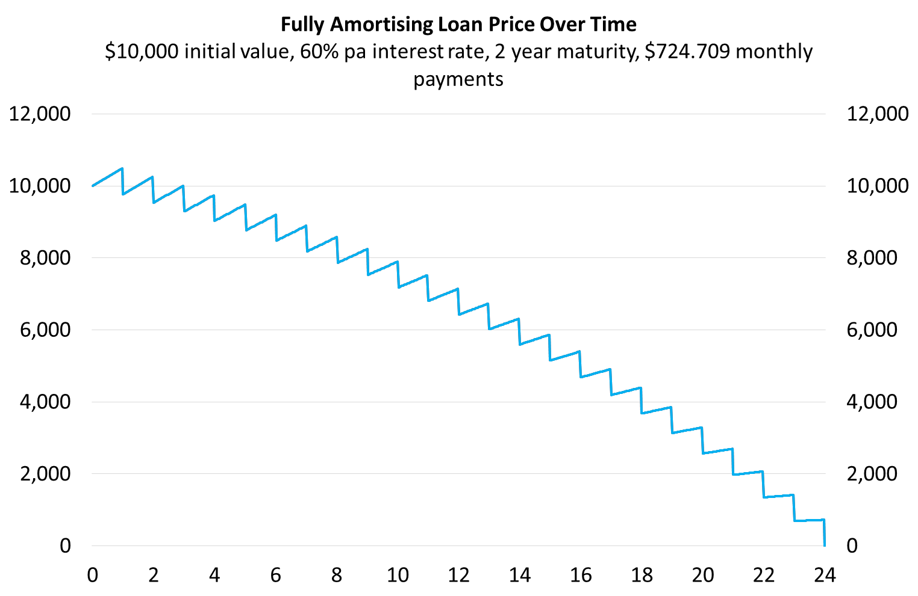
Interest and Principal Components
Each total loan payment ($C_{total}$) can be broken into interest ($C_{interest}$) and principal ($C_{principal}$) components:
$$C_{total}=C_{interest}+C_{principal}$$
The interest component at time one ($C_{1interest}$) is defined as the interest rate over the first period ($r_{0→1}$) multiplied by the initial (time zero) loan price or value ($V_{0}$):
$$C_{1interest}=V_{0}.r_{0→1}$$
The principal component is the remaining part:
$$C_{1principal}=C_{total}-C_{1interest}$$
For a general formula, replace time 1 with $t$ and 0 with $t-1$.
Calculation Example: Loan Schedule
Fully Amortising Home Loan Schedule
$1 million initial value, 3.6% pa interest rate, 30 year maturity, monthly payments
Time | Value | Total payment | Interest component | Principal component
months | $ | $/month | $/month | $/month
0 | 1000000.00
1 | 998453.55 | 4546.45 | 3000.00 | 1546.45
2 | 996902.45 | 4546.45 | 2995.36 | 1551.09
3 | 995346.71 | 4546.45 | 2990.71 | 1555.75
4 | 993786.29 | 4546.45 | 2986.04 | 1560.41
5 | 992221.20 | 4546.45 | 2981.36 | 1565.09
… | … | … | … | …
357 | 13557.93 | 4546.45 | 54.15 | 4492.30
358 | 9052.15 | 4546.45 | 40.67 | 4505.78
359 | 4532.85 | 4546.45 | 27.16 | 4519.30
360 | 0.00 | 4546.45 | 13.60 | 4532.85
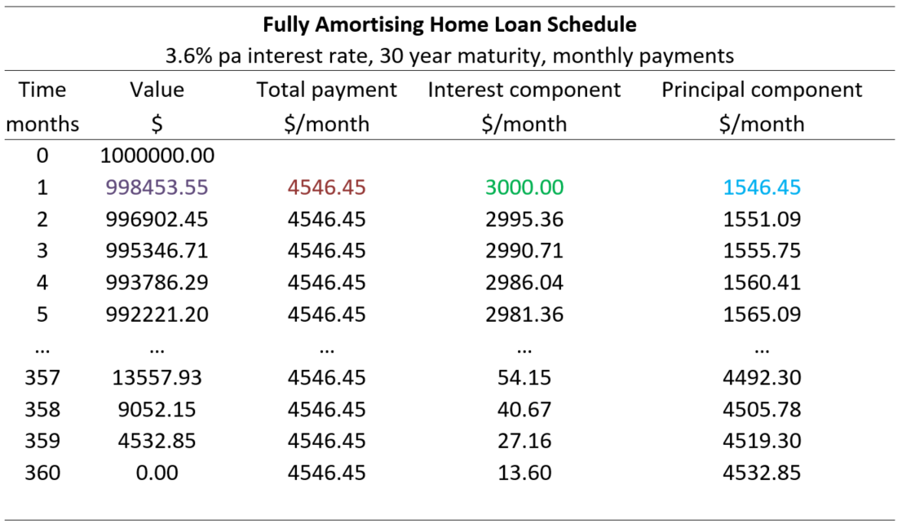
$C_{1total}=\frac{V_{0}}{\frac{1}{r_{eff monthly}}\left(1-\frac{1}{{\left(1+r_{eff monthly}\right)}^{T_{months}}}\right)}$
$= \frac{1,000,000}{\frac{1}{\left(\frac{0.036}{12}\right)}\left(1-\frac{1}{{\left(1+\frac{0.036}{12}\right)}^{30×12}}\right)}=4,546.45$
$C_{1interest}=V_{0}.r_{eff monthly, 0→1}=V_{0}.\frac{r_{APR comp monthly, 0→1}}{12}$
$=1,000,000×\frac{0.036}{12}=3,000$
$C_{1principal}=C_{1total}-C_{1interest}$
$$=4,546.45-3,000$$
$=1,546.45$
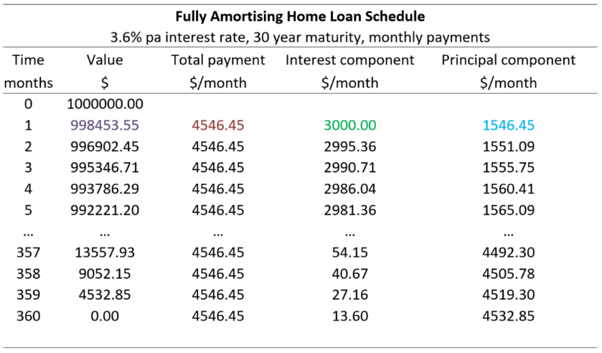
Loan Valuation: Prospective vs Retrospective
Prospective loan valuation: The value (price) of any asset is the present value of its future cash flows.
So discount the future cash flows to the present. For example, to find the month 1 loan value just after that first payment:
$V_{1}=\frac{C_{2}}{r_{eff monthly}}\left(1-\frac{1}{{\left(1+r_{eff monthly}\right)}^{T_{months remaining}}}\right)$
$= \frac{4,546.4535}{\left(\frac{0.036}{12}\right)}\left(1-\frac{1}{{\left(1+\frac{0.036}{12}\right)}^{30×12-1}}\right)=998,453.55$

Retrospective loan valuation: Deduct the principal portion of the loan payment from the prior value:
$$V_{1}=V_{0}-C_{1principal}$$
$=1,000,000-1,546.45=998,453.55$
Comment: Prospective over Retrospective
The retrospective method only works when credit risk remains unchanged and everything goes to plan.
Using the home loan in the previous example, say a volcano explodes underneath the borrower’s house and they lose their job at month 4 just after the payment at that time, and they only have enough savings for one more monthly loan payment.
The prospective method would correctly value the month 4 loan as the present value of that one remaining $4,546.45 month 5 payment, since the remaining payments at month 6, 7 and so on will not occur and there’s no property to re-possess.
But the retrospective method would incorrectly value the month 4 loan at $993,786.29 which is far too high.
The retrospective method should be discouraged since past cash flows are sunk and shouldn’t be considered when pricing assets. Always think about the future, not the past.

Questions: Fully Amortising Loans
http://www.fightfinance.com/?q=19,87,134,149,172,187,203,204,222,259,

Interest-Only Loans
Borrowers with interest-only loans don’t make any principal payments. Their entire loan payments are interest. So the loan is not paid off until the very last payment when the original amount must be fully repaid, plus the interest over that last month.
Often this big amount is paid off by re-financing (rolling over) the debt which means borrowing again, or by selling the house.
Most interest-only loans in Australia are actually interest-only for 5 years or less. After this, they convert to fully amortising loans.
Interest-Only Loans Valuation
Interest only loans are easily valued using the ‘perpetuity without growth’ formula:
$$V_{0 interest only}=\frac{C_{1}}{r}=\frac{C_{1 monthly}}{r_{eff monthly}}=\frac{C_{1 monthly}}{\left(\frac{r_{APR comp monthly}}{12}\right)}$$
This makes sense since an interest-only loan that is repeatedly refinanced always has the same principal, it’s never paid off. If the interest rate is constant forever, then the borrower will pay constant interest cash flows $(C_{1}=C_{2}=C_{3}=…)$ perpetually.
Another way of looking at the interest-only loan is to assume that the final principal payment is paid off without refinancing. The initial price ($V_{0}$) is the present value of the interest payments ($C_{1}$, $C_{2},$…) and also the final principal ($V_{T}$):

$$V_{0}=\frac{C_{1}}{r}\left(1-\frac{1}{{\left(1+r\right)}^{T}}\right)+\frac{V_{T}}{{\left(1+r\right)}^{T}}$$
Substitute $V_{T}=V_{0}$
$$V_{0}=\frac{C_{1}}{r}\left(1-\frac{1}{{\left(1+r\right)}^{T}}\right)+\frac{V_{0}}{{\left(1+r\right)}^{T}}$$
$$V_{0}-\frac{V_{0}}{{\left(1+r\right)}^{T}}=\frac{C_{1}}{r}\left(1-\frac{1}{{\left(1+r\right)}^{T}}\right)$$
$$V_{0}\left(1-\frac{1}{{\left(1+r\right)}^{T}}\right)=\frac{C_{1}}{r}\left(1-\frac{1}{{\left(1+r\right)}^{T}}\right)$$
$$V_{0}=\frac{C_{1}}{r}$$

Calculation Example: Interest Only Loans
Question: Using the same data as before, what is the most that you can borrow using an interest only mortgage loan? Again, assume constant interest rates.
Answer: Interest-only loans are equivalent to perpetuities with no growth.
$$V_{0 interest only}=\frac{C_{1}}{r}=\frac{C_{1 monthly}}{r_{eff monthly}}=\frac{C_{1 monthly}}{\left(\frac{r_{APR comp monthly}}{12}\right)}$$
$$=\frac{2000}{(0.06/12)}=\$400,000$$

Calculation Example: Interest Only Loans
Question: You wish to borrow $10,000 for 2 years as an unsecured personal loan.
Interest rates are quite expensive at 60% pa and are not expected to change.
What will be your monthly payments on an interest-only loan?
Answer:
$$V_{0 finterest only}=\frac{C_{1}}{r}$$
$$10000 =\frac{C_{1}}{0.6/12}$$
$$C_{1} =10000×0.6/12=500$$
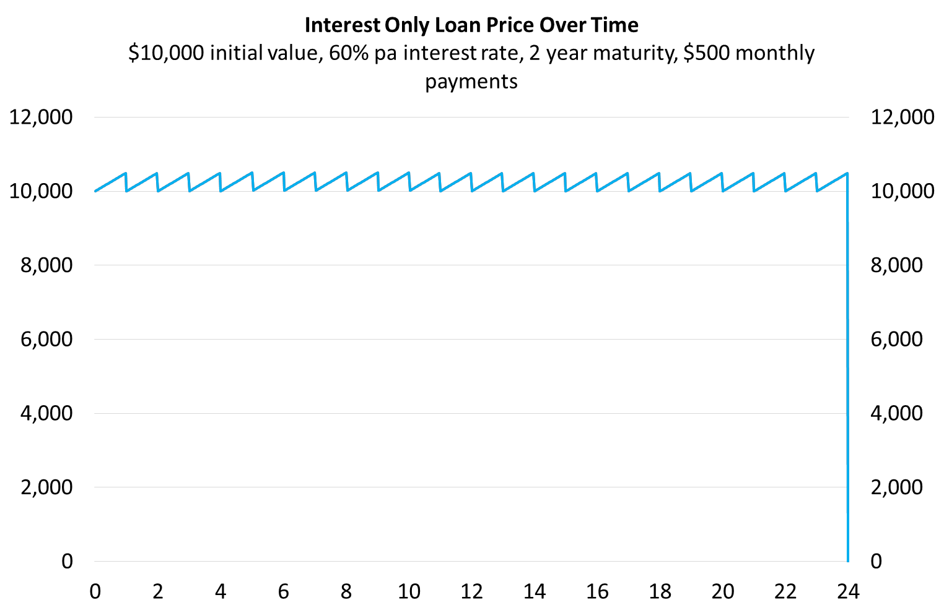
Calculation Example: Loan Schedule
Interest-Only Home Loan Schedule
$1 million initial value, 3.6% pa interest rate, 30 year maturity, monthly payments
Time | Value | Total payment | Interest component | Principal component
months | $ | $/month | $/month | $/month
0 | 1000000.00
1 | 1000000.00 | 3000.00 | 3000.00 | 0.00
2 | 1000000.00 | 3000.00 | 3000.00 | 0.00
3 | 1000000.00 | 3000.00 | 3000.00 | 0.00
4 | 1000000.00 | 3000.00 | 3000.00 | 0.00
5 | 1000000.00 | 3000.00 | 3000.00 | 0.00
… | … | … | … | …
357 | 1000000.00 | 3000.00 | 3000.00 | 0.00
358 | 1000000.00 | 3000.00 | 3000.00 | 0.00
359 | 1000000.00 | 3000.00 | 3000.00 | 0.00
360 | 0.00 | 1003000.00 | 3000.00 | 1000000.00
$C_{1total}=V_{0}.r_{eff monthly, 0→1}=V_{0}.\frac{r_{APR comp monthly, 0→1}}{12}$
$= 1,000,000×\frac{0.036}{12}=3,000$
$C_{1interest}=V_{0}.r_{eff monthly, 0→1}=V_{0}.\frac{r_{APR comp monthly, 0→1}}{12}$
$=1,000,000×\frac{0.036}{12}=3,000$
$C_{1principal}=C_{1total}-C_{1interest}$
$=3,000 -3,000=0$

Questions: Interest Only Loans
http://www.fightfinance.com/?q=29,42,57,107,160,239,298,459,

Bond Pricing exactly one period before the next coupon
The price of a bond is the present value of the coupons and the principal. The coupons are an annuity and the principal (also called the face or par value) is a single payment, therefore:
$$P_{0, bond}=PV\left(annuity of coupons\right)+PV\left(principal\right)$$
$$=\frac{C_{1}}{r_{eff}}\left(1-\frac{1}{{\left(1+r_{eff}\right)}^{T}}\right) + \frac{{Face}_{T}}{{\left(1+r_{eff}\right)}^{T}}$$
Note that this equation assumes that the next coupon is paid in exactly one period. This will be the case for a bond that was just issued or a bond that just paid a coupon.
Care must be taken when choosing $r_{eff}$ and T so that they are consistent with the time period between coupon payments ($C_{1}$).
Remember that bond yields are given as APR's compounding at the same frequency as coupons are paid, so they normally have to be converted to effective rates before using them in the above equation.

Bond Pricing Conventions
US, Japanese and Australian fixed coupon bonds often pay semi-annual coupons. Therefore the yields are quoted as APR's compounding semi-annually.
Many European bonds often pay annual coupons. Therefore the yields are quoted as APR's compounding annually, which is the same thing as an effective annual rate.

Calculation Example: Bond Pricing exactly one period before the next coupon
Question: An Australian company issues a fixed-coupon bond. The bond will mature in 3 years, has a face value of $1,000 and a coupon rate of 8% pa paid semi-annually. Yields are currently 5% pa. What is the price of the bond?
Answer: Each 6 month coupon will be:
$$C_{semi-annual}=Face value×\frac{coupon rate}{2}$$
$$=1,000×\frac{0.08}{2}=\$40$$

The number of time periods T must be consistent with the coupon payment frequency of 6 month periods, so
$$T=3 years ×2$$
$=6$ semi-annual periods
The yield of 5% pa can be assumed to be an APR compounding every 6 months, the same frequency as the coupon payments. We need to find the effective 6 month rate to discount the 6-month coupons, so:
$$r_{eff 6month}=r_{APR comp semi annually}÷2$$
$$=0.05÷2=0.025$$

To find the bond price,
$${Price}_{bond}=PV\left(annuity of coupons\right)+PV\left(principal\right)$$
$$=\frac{C_{1}}{r_{eff}}\left(1-\frac{1}{{\left(1+r_{eff}\right)}^{T}}\right) + \frac{Face_{T}}{{\left(1+r_{eff}\right)}^{T}}$$
$$=\frac{1000×0.08/2}{0.05/2}\left(1-\frac{1}{{\left(1+0.05/2\right)}^{3×2}}\right)+\frac{1000}{{\left(1+0.05/2\right)}^{3×2}}$$
$$=\frac{40}{0.025}\left(1-\frac{1}{{\left(1+0.025\right)}^{6}}\right) + \frac{1,000}{{\left(1+0.025\right)}^{6}}$$
$$=220.3250145 + 862.296866$$
$$=\$1,082.62$$

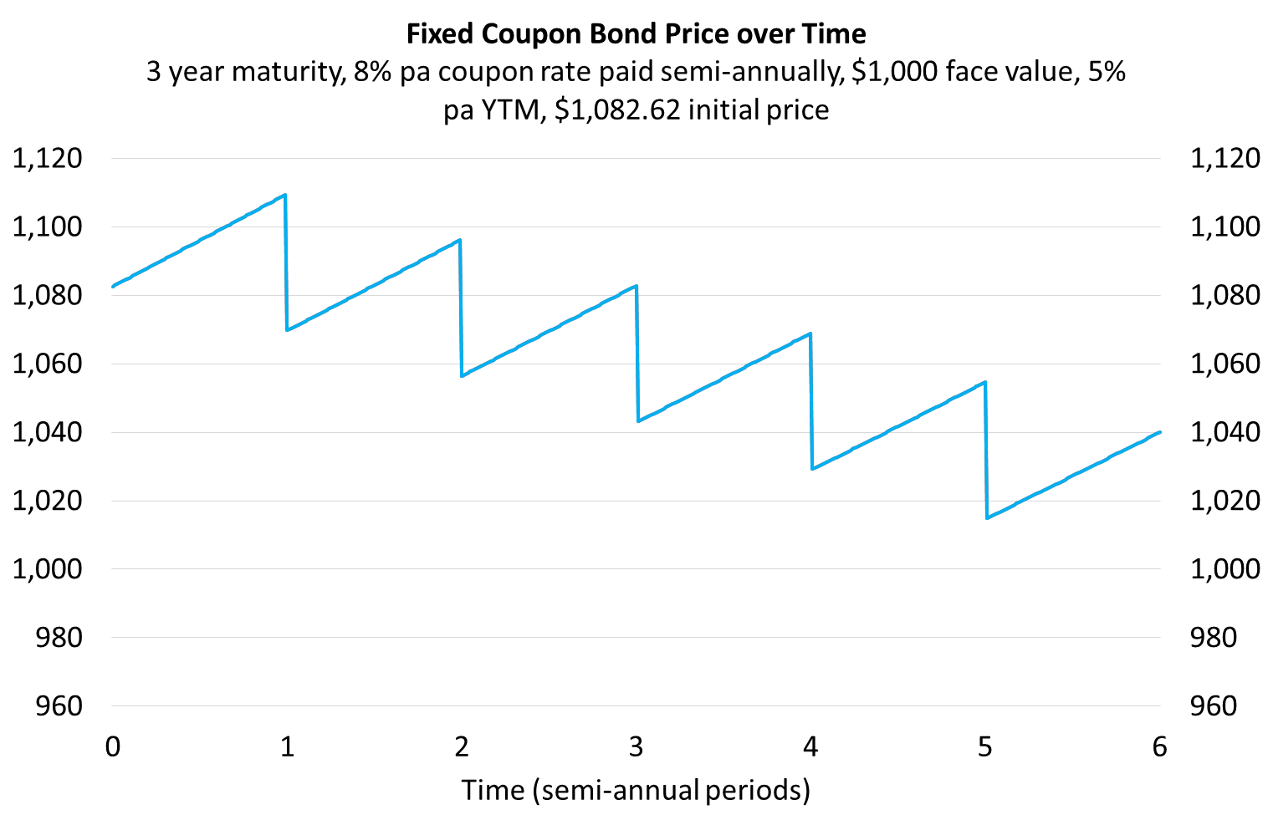
Bond Yields and Coupon Rates - Important
A company issues three similar bonds which differ only in their coupon rates. Coupons are paid semi-annually.
Bond | Maturity or tenor | Yield to maturity | Coupon  rate | Face or par value | Price | Bond type
 | (years) | (% pa) | (% pa) | ($) | ($)
A | 3 | 5 | 0 | 100 | 86.23 | Discount
B | 3 | 5 | 5 | 100 | 100.00 | Par
C | 3 | 5 | 10 | 100 | 113.77 | Premium
Discount bonds: CouponRate < YTM, Price < FaceValue
Par bonds: CouponRate = YTM, Price = FaceValue
Premium bonds: CouponRate > YTM, Price > FaceValue
P_{0A} = 100/(1+0.05/2)^(3*2) = 86.2297
P_{0B} = 100*0.05/2 * 1/(0.05/2)*(1-1/(1+0.05/2)^(2*3)) + 100/(1+0.05/2)^(3*2) = 100
P_{0C} = 100*0.1/2 * 1/(0.05/2)*(1-1/(1+0.05/2)^(2*3)) + 100/(1+0.05/2)^(3*2) = 113.7703
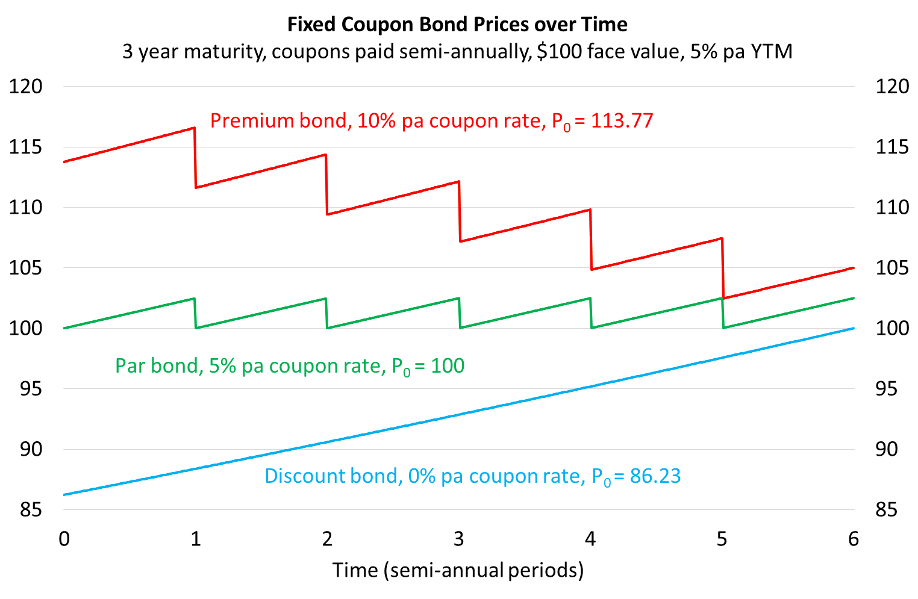
Calculation Example: Bonds issued at par
Question: An Australian company issues a bond at par. The bond will mature in 3 years, has a face value of $1,000 and a coupon rate of 8%. What is the price of the bond?
Answer: This is a trick question, no calculations are required. Since the bond was issued at par, the price must be equal to the face value. Therefore the price is $1,000. Current yields in the bond market must also be equal to 8% pa, the same as the bond's coupon rate.

Calculation Example: Zero coupon bonds
Question: An Australian company issues a zero coupon bond. The bond will mature in 3 years and has a face value of $1,000. If the current price of the bond is $700, what is the current yield on the bond, given as an APR compounding semi-annually?
Answer: Zero coupon bonds pay no coupons. Therefore the price of the bond is just the present value of the principal.
To find current yields we need to solve for the discount rate:
$${Price}_{bond} =PV\left(annuity of coupons\right)+PV\left(principal\right)$$
$$=0+\frac{Face}{{\left(1+r_{eff}\right)}^{T}}$$
$$700 =\frac{1,000}{{\left(1+r_{eff 6mth}\right)}^{6}}$$
$${700×\left(1+r_{eff 6mth}\right)}^{6}=1,000$$
$${\left(1+r_{eff 6mth}\right)}^{6}=\frac{1,000}{700}$$
$$1+r_{eff 6mth}={\left(\frac{1,000}{700}\right)}^{\frac{1}{6}}$$
$$r_{eff 6mth}={\left(\frac{1,000}{700}\right)}^{\frac{1}{6}}-1$$
$$=0.061248265$$
We need to convert this rate to an APR compounding every 6 months since that is how bond yields are quoted in Australia.
$$r_{APR comp per 6mths}=r_{eff 6mth}×2$$
$$=0.061248265×2$$
$$=0.12249653=12.249653\%$$
For the exam, note that you will not be asked to find the yield on coupon-paying bonds since that requires trial-and-error or a computer that can do it for you (use a spreadsheet's IRR or YIELD formula).
But you may be asked to find the yield on a simple zero coupon bond like we did in this question.
Note that instead of finding the effective semi-annual rate and converting to an APR compounding semi-annually at the end, the bond pricing equation can be set up so that the APR compounding semi-annually is calculated from the start:
$$700 =\frac{1,000}{{\left(1+\frac{r_{APR comp 6mth}}{2}\right)}^{6}}$$
$$r_{APR comp 6mth}=2\left({\left(\frac{1,000}{700}\right)}^{\frac{1}{6}}-1\right)$$
$$=2×0.061248265$$
$$=0.12249653$$
$$=12.249653\%$$
Questions: Bond Pricing
http://www.fightfinance.com/?q=509,510,11,15,23,33,38,48,53,56,63,133,138,153,159,163,168,178,179,183,193,194,207,213,227,229,230,233,255,257,266,287,328,332,460,

Bond Pricing in between coupons
To price a bond in between coupon periods at time t, grow the bond price $P_{0}$ forward by the yield to maturity:
$P_{t} =P_{0}{\left(1+r_{eff}\right)}^{t}$ where:
$P_{t}$ is the bond price at the current time t and 0<t<1;
$C_{1}$ is the next coupon payment at time one;
T is the number of coupons remaining to be paid;
$r_{eff}$ is the yield to maturity as an effective rate per coupon period;
$P_{0}$ is the bond price one period before the next coupon $C_{1}$;
$$P_{0} =\frac{C_{1}}{r_{eff}}\left(1-\frac{1}{{\left(1+r_{eff}\right)}^{T}}\right)+\frac{F_{T}}{{\left(1+r_{eff}\right)}^{T}}$$
Calculation Example: Bond pricing in between coupons
Question: A 3 year government bond paying 10% pa semi-annual coupons with a face value of $100 was issued 4 months ago at a yield of 5% pa. Find the current price of the bond.
Ignore the actual number of days in each month and assume that every month is 1/12 of a year.
Answer: Let the next coupon payment in 6 months be time 1. Let’s find the bond price one (semi-annual) coupon period before, which is time zero, with 6 semi-annual coupons left:
$$P_{0}=\frac{0.1×100/2}{0.05/2}\left(1-\frac{1}{{\left(1+0.05/2\right)}^{3×2}}\right)+\frac{100}{{\left(1+0.05/2\right)}^{3×2}}$$
$$P_{0}=\frac{0.1×100/2}{0.05/2}\left(1-\frac{1}{{\left(1+0.05/2\right)}^{3×2}}\right)+\frac{100}{{\left(1+0.05/2\right)}^{3×2}}$$
$$=\frac{5}{0.025}\left(1-\frac{1}{{\left(1+0.025\right)}^{6}}\right)+\frac{100}{{\left(1+0.025\right)}^{6}}$$
$$=113.770313404$$
Now grow the bond price that extra 4 months forward, which is 4/6 (=0.66667) semi-annual periods, to get to the current time:
$$P_{4months}=P_{0}{\left(1+r_{APR comp 6 months}/2\right)}^{4/6}$$
$$=113.770313404×{\left(1+0.05/2\right)}^{4/6}$$
$$=115.6586711$$
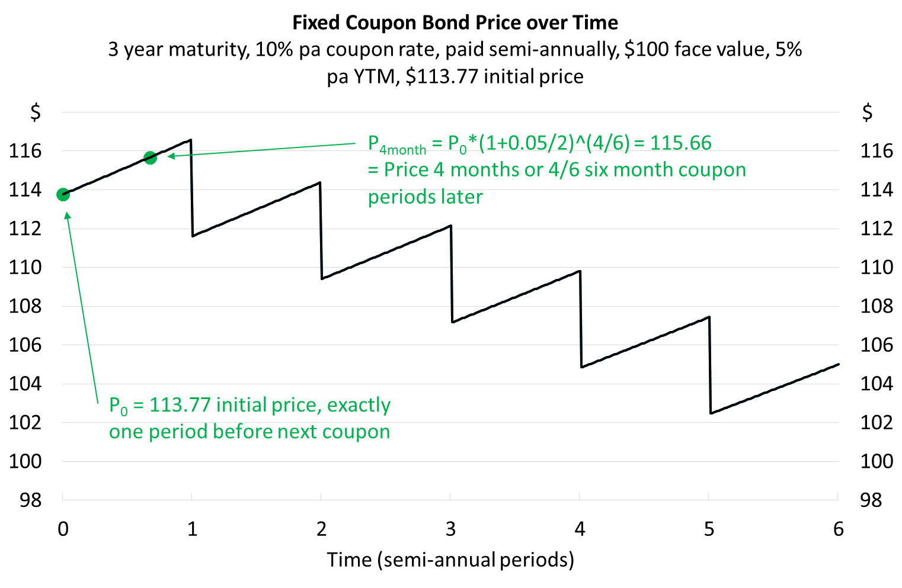
Calculation Example: Bond pricing in between coupons
Question: A 10 year government bond paying 3% pa semi-annual coupons with a face value of $100 was issued 8 months ago on 15 December 2021 at a yield of 3% pa.
Today is 15 August 2022 and yields are now 2.8% pa. What is the current price of the bond?
Ignore the actual number of days in each month and assume that every month is 1/12 of a year, so the bond was issued 8 months ago from today, 15 August 2022.

Answer: Let the issue date 15 December 2021 be time zero. There are only 19 semi-annual coupons left, since the first was already paid on 15 June 2022. The bond’s next coupon ($C_{2}$) will be paid on 15 December 2022. The bond price one period before coupon $C_{2}$ is:
$$P_{1}=\frac{C_{2}}{r_{eff}}\left(1-\frac{1}{{\left(1+r_{eff}\right)}^{19}}\right)+\frac{F_{19}}{{\left(1+r_{eff}\right)}^{19}}=P_{\begin{aligned}15Jun2022, \\ 6 months \\ after issue\end{aligned}}$$
$$=\frac{0.03×100/2}{0.028/2}\left(1-\frac{1}{{\left(1+0.028/2\right)}^{19}}\right)+\frac{100}{{\left(1+0.028/2\right)}^{19}}$$
$$=24.87274706+76.78543608=101.6581831$$
$$P_{1.3333}=P_{1}{\left(1+0.028/2\right)}^{0.3333}=P_{\begin{aligned}15Aug2022, \\ 8 months \\ after issue\end{aligned}}$$
$$=101.6581831×{\left(1+0.028/2\right)}^{2/6}=102.1303912$$
The subscripts are in coupon periods so they correspond to the graph and exponents shown in the formula. So for example:
- $P_{0}$ is the initial price when the bond was issued on 15 December 2021.
- $P_{1}$ is the price 1 semi-annual period (6 months) after the bond was issued and corresponds to 15 June 2022.
- $P_{1.3333}$ is the price 1.3333 semi-annual period (8 months) after the bond was issued and corresponds to 15 August 2022. It’s the current time that we’re trying to price the bond.
- $C_{2}$ is the coupon 2 semi-annual periods (1 year) after the bond was issued and corresponds to 15 December 2022.
The graph helps visualize the problem.
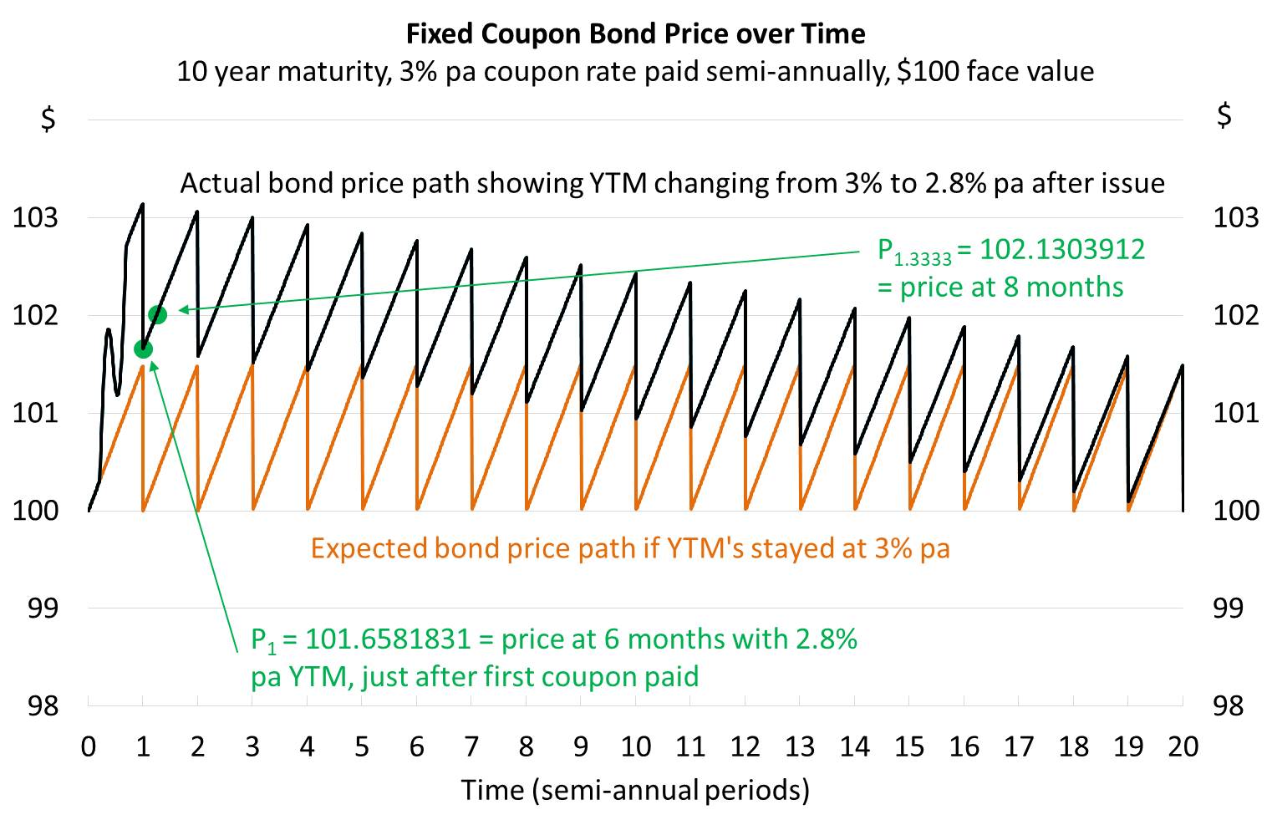
Debt Overview
The debt markets are far more complicated and filled with jargon than the equity markets.
It's important to be aware of all of the different ways debt can be classified. For example:
- Retail or wholesale
- Long or short term original maturity
- Floating or fixed coupons
- Secured or unsecured
- Premium, par or discount
- Call-able, put-able or vanilla
- Seniority: Senior, mezzanine, subordinated.
- Securities such as bonds and notes which are fungible and saleable (negotiable). Instruments, a broad category that encompasses securities and also loans and bills which are not fungible.
- Rated and un-rated.
Some strange things about debt markets:
- Risk is not usually quoted as a standard deviation or variance or beta, but as a 'rating'.
- Rating agencies S&P and Fitch use ratings:
  - AAA, AA+, AA, AA-, A+, A, A-, BBB+, BBB, BBB-, BB+, …
- Moodys uses ratings:
  - Aaa, Aa1, Aa2, Aa3, A1, A2, A3, Baa1, Baa2, Baa3, Ba1, …
- Interest rates are quoted differently depending on the market and might be given as Annualised Percentage Rates (APR's, especially in the bond market) or simple interest rates (money market).
- Debt markets trade on yields and prices based a number of days per year that could be 360 days a year, 365 days a year, or the actual days in the year, depending on the country and market.

Wholesale Debt Securities
Wholesale debt securities are traded by big financial institutions. They can be classified as being 'money market' or 'bond' securities depending on their original maturity. The Reserve Bank defines bond market debt as having an original maturity of more than one year.
Short term wholesale debt securities
Bills, commonly Bank Accepted Bills (BAB's)
Certificates of Deposit (CD's)
Promissory Notes (PN's)
Long term wholesale debt securities
Bonds, Debentures.
Short Term Wholesale Debt Securities
Short term wholesale debt securities usually have a maturity of less than 1 year when issued, such as:
- Bills, commonly Bank Accepted Bills (BAB's);
- Certificates of Deposit (CD's);
- Promissory Notes (PN's); and
- Treasury Bills (TB’s).
Yields are quoted as simple annual rates, which are mathematically different to compound rates such as effective rates and annualized percentage rates (APR's).

These short term debt securities do not pay coupons and are therefore 'discount securities', which means that their price is less than their face value, assuming positive yields ($r_{simple}>0$).
$${Price}_{bill}=V_{0}=\frac{F_{d}}{\left(1+r_{simple}×\frac{d}{365}\right)}$$
Where $F_{d}$ is the face value, $r_{simple}$ is the simple annual interest rate and d is days until maturity.

Calculation Example: Bank Accepted Bills (BAB's)
Question: A company issues a bill which is accepted (guaranteed) by a bank. The BAB will mature in 90 days, has a face value of $1 million and an interest rate of 7% pa. What is the price of the bill?
Answer:
$$P_{0}=\frac{F_{d}}{\left(1+r_{simple}×\frac{d}{365}\right)}$$
$$=\frac{1,000,000}{\left(1+0.07×\frac{90}{365}\right)}=983,032.5882$$
Long-term Wholesale Debt Securities
Usually have an original maturity of more than 1 year. They're commonly known as bonds.
Yields to maturity (YTM’s, often just called interest rates) are conventionally quoted as annualized percentage rates (APR's), compounding at the same frequency as the coupons are paid.
If an 8% APR compounds semi-annually, then the effective 6 month rate will be 4% per six months. You must convert APR’s into effective rates before using them in the bond pricing formula:
$$P_{0, bond}=PV\left(annuity of coupons\right) +PV\left(principal\right)$$
$$=\frac{C_{1}}{r_{eff}}\left(1-\frac{1}{{\left(1+r_{eff}\right)}^{T}}\right) + \frac{{Face}_{T}}{{\left(1+r_{eff}\right)}^{T}}$$
Most bonds pay coupons. Coupon payments are calculated as the face value multiplied by the coupon rate.
$$C_{1annual}=AnnualCoupon=CouponRatePerAnnum×{Face}_{T}$$
If the coupons are paid semi-annually, then half of the total coupon is paid every 6 months.
$$C_{1 semi annual}=SemiAnnualCoupon=\frac{CouponRatePerAnnum×{Face}_{T}}{2}$$
Coupon rates are commonly confused with YTM’s, but they are different. Coupon rates are just a convenient way to specify coupon payments.

Term Structure of Interest Rates
Long term interest rates are based on expectations of future short term interest rates.
We will discuss spot and forward rates, yield curves, and then two important theories of interest rates:
- Expectations hypothesis
- Liquidity premium theory
Another theory that we won’t discuss is the ‘segmented markets’ theory.
Spot and Forward Interest Rates
Spot rate: An interest rate measured from now until a future time. For example, a 3-year zero-coupon bond with a yield of 8% pa has a 3-year pa spot rate of $r_{0-3,yearly}=0.08$ pa. Note that spot rates can be from now until any future time.
Forward rate: An interest rate measured from a future time until a more distant future time. For example, if a company promised, one year from now, to issue a 3-year zero-coupon bond with a yield of 8% pa, then the forward rate from years 1 to 4 would be $r_{1-4,yearly}=0.08$. Forward rates are sometimes written with an 'f' rather than 'r'.
Spot and forward rates can be quoted as APR's or effective rates.
Term Structure of Interest Rates: The Expectations Hypothesis
Expectations hypothesis is that long term spot rates (plus one) are the geometric average of the shorter term spot and forward rates (plus one) over the same time period. Mathematically:
$$1+r_{0→T}={\left(\left(1+r_{0→1}\right)\left(1+r_{1→2}\right)\left(1+r_{2→3}\right)...\left(1+r_{\left(T-1\right)→T}\right)\right)}^{\frac{1}{T}}$$
or
$${\left(1+r_{0→T}\right)}^{T}=\left(1+r_{0→1}\right)\left(1+r_{1→2}\right)\left(1+r_{2→3}\right)…(1+r_{\left(T-1\right)→T})$$
Where T is the number of periods and all rates are effective rates over each period.
Calculation Example: Term Structure of Interest Rates
Question: The following US Government Bond yields were quoted on 5/3/2012 (sourced from Bloomberg):
- 6-month zero-coupon bonds yielded 0.11%.
- 12-month zero-coupon bonds yielded 0.16%.
Find the forward rate from month 6 to 12. Quote your answer as a yield in the same form as the above yields are quoted.
Remember that US (and Australian) bonds normally pay semi-annual coupons.

Answer: Even though these are zero-coupon bonds, since they are US bonds the yield would be quoted as an APR compounding semi-annually since all coupon bonds pay semi-annual coupons. This means that our answer should be quoted in the same form, as an APR compounding semi-annually.
Therefore we have to convert the APR compounding every 6 months to an effective 6 month yield by dividing it by 2.
$$r_{0→0.5yr,eff 6mth}=\frac{r_{0→0.5yr,APR comp semi-annually}}{2}$$
$$=\frac{0.0011}{2}=0.00055$$

$$r_{0→1yr,eff 6mth}=\frac{r_{0→1yr,APR comp semi-annually}}{2}$$
$$=\frac{0.0016}{2}=0.0008$$
We want to find $r_{0.5yr→1yr,eff 6mth}$, which is the effective 6 month forward rate over the second 6 month period (0.5 years to 1 year).
Applying the term structure of interest rates equation:
$${\left(1+r_{0→T}\right)}^{T}=\left(1+r_{0→1}\right)\left(1+r_{1→2}\right)\left(1+r_{2→3}\right)…(1+r_{\left(T-1\right)→T})$$
$${\left(1+r_{0→1yr,eff 6mth}\right)}^{2}=\left(1+r_{0→0.5yr, eff 6mth}\right)\left(1+r_{0.5→1yr, eff 6mth}\right)$$
$${\left(1+0.0008\right)}^{2}=\left(1+0.00055\right)\left(1+r_{0.5→1yr, eff 6mth}\right)$$
$$r_{0.5→1yr, eff 6mth}=\frac{{\left(1+0.0008\right)}^{2}}{\left(1+0.00055\right)}-1$$
$=0.001050062$
But this is an effective 6 month rate. Let's convert it to an APR compounding every 6 months.
$$r_{0.5→1yr,APR comp 6mths}=r_{0.5→1yr, eff 6mth}×2$$
$$=0.001050062×2$$
$$=0.002100124=0.21\%pa$$
Note that this forward rate APR from 0.5 years to 1 year is bigger than both of the bond yield APR's (which are spot rates). This makes sense since we have a normal upward sloping yield curve $(r_{0→0.5yr}<r_{0→1yr})$ so the forward rate $(r_{0.5→1yr})$ should be greater than the spot rates $(r_{0→0.5yr} and r_{0→1yr})$.

Quick method: Convert rates in the term structure equation
Interest rate conversion from anualised percentage rates (APR’s) to effective returns can be a headache. Most people prefer to do the APR to effective rate conversion in the expectations formula itself:
$${\left(1+r_{0→T eff}\right)}^{T}=\left(1+r_{0→1 eff}\right)\left(1+r_{1→2 eff}\right)…(1+r_{\left(T-1\right)→T eff})$$
$${\left(1+r_{0→1yr,eff 6mth}\right)}^{2}=\left(1+r_{0→0.5yr, eff 6mth}\right)\left(1+r_{0.5→1yr, eff 6mth}\right)$$
$${\left(1+\frac{r_{0→1yr,APR 6mths}}{2}\right)}^{2}=\left(1+\frac{r_{0→0.5yr,APR 6mths}}{2}\right)\left(1+\frac{r_{0.5→1yr, APR 6mths}}{2}\right)$$
$${\left(1+\frac{0.0016}{2}\right)}^{2}=\left(1+\frac{0.0011}{2}\right)\left(1+\frac{r_{0.5→1yr, APR 6mths}}{2}\right)$$
$$r_{0.5→1yr, APR 6mths}=\left(\frac{{\left(1+\frac{0.0016}{2}\right)}^{2}}{\left(1+\frac{0.0011}{2}\right)}-1\right)×2=0.002100124$$
This forward rate from 6 months to one year is 0.21% pa given as an APR compounding every 6 months.

Yield Curves
Yield curves show the behaviour of short and long-term interest rates and can give an indication of expected future interest rates.
Yield curves can be flat, normal, inverse, or some combination. The x-axis of a yield curve is the time to maturity of the bond, and the y-axis is the yield of the bond.
A flat yield curve is a straight horizontal line. Short and long term spot rates are equal, and yearly spot and forward rates are also equal. Other names for flat interest rates are 'constant', 'unchanging', or 'level' interest rates.
A normal yield curve is an upward sloping line or curve. Short term spot rates are less than long term spot rates. Yearly spot rates are less than yearly forward rates. Other names for normal yield-curves are 'upward sloping' or 'steep ' yield curves. These yield curves are 'normal' since yields usually exhibit this behaviour.
An inverse yield curve is a downward sloping line or curve. Short term spot rates are more than long term spot rates. Yearly spot rates are more than yearly forward rates. Other names for inverse yield-curves are 'downward sloping' or 'inverted ' yield curves.
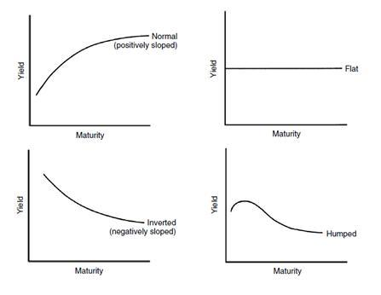
An Extension: Liquidity Premium Theory
The expectations hypothesis assumes that investors are indifferent between investing in a 10 year bond, or investing in a one year bond, then investing in another 1 year bond after the first is repaid, and so on for 10 years.
Most investors would prefer to lend lots of short term bonds repeatedly rather than one big long one. The reason is that the long-term bond locks up the investor's cash and she loses the option to change her mind and do something else with the cash.
The liquidity premium theory suggests investors are only enticed to lend their cash out long-term if they are rewarded for doing so in the form of higher long-term rates compared to short term rates. This means that forward rates will be higher than the expected spot rates over the same time period.
For example, if the forward rate from years 1 to 2 is 8% now, then 1 year later the spot rate (from years 0 to 1) would tend to be less, say 7.5%.
This theory explains why the up-ward sloping yield curve is normal, since spot rates would tend to be less than forward rates.

Real World Example: Yield Curves and Term Structure of Interest Rates
See the below sources for an interesting view of yield curves and the term structure of interest rates.

Australian Federal Government (Fixed Coupon) Bond Yields:
http://www.bloomberg.com/markets/rates-bonds/government-bonds/australia

Table of yields on evening of 5/3/2012. Source: Bloomberg.

Australian Government Bonds
 | COUPON | MATURITY | PRICE/YIELD | PRICE/YIELD CHANGE | TIME
3-Month | 0.000 | 06/08/2012 | 4.15 / 4.15 | 98.943 / 4.150 | 02/24
1-Year | 6.500 | 05/15/2013 | 103.06 / 3.83 | 0.058 / -0.055 | 00:39
2-Year | 6.250 | 06/15/2014 | 105.48 / 3.71 | 0.131 / -0.061 | 00:39
3-Year | 6.250 | 04/15/2015 | 107.39 / 3.71 | 0.181 / -0.062 | 00:39
4-Year | 4.750 | 06/15/2016 | 103.87 / 3.76 | 0.237 / -0.060 | 00:39
5-Year | 6.000 | 02/15/2017 | 109.95 / 3.77 | 0.284 / -0.061 | 00:39
6-Year | 5.500 | 01/21/2018 | 108.60 / 3.85 | 0.374 / -0.069 | 00:39
7-Year | 5.250 | 03/15/2019 | 108.25 / 3.90 | 0.452 / -0.071 | 00:39
8-Year | 4.500 | 04/15/2020 | 103.63 / 3.97 | 0.537 / -0.077 | 00:39
10-Year | 5.750 | 05/15/2021 | 113.05 / 4.04 | 0.649 / -0.080 | 00:39
15-Year | 4.750 | 04/21/2027 | 103.53 / 4.43 | 0.931 / -0.084 | 00:38

Orange line: current yield, Green line: previous close (yesterday's) yield. As at 5/3/2012. Note the humped curve.
