***Capital Asset Pricing Model***

* Systematic and idiosyncratic variance, Beta interpretation.
* Total, systematic and idiosyncratic variance.
* Excess returns and Jensen’s alpha.
* How CAPM extends Markowitz portfolio theory.
* Cost of equity and debt using CAPM and DDM.
* Probabilities and returns in different states of the world.

***Capital Asset Pricing Model (CAPM)***

The CAPM separates total variance into two types:

**Systematic variance**

* Also called market or undiversifiable variance. This risk can not be avoided and affects all assets except treasury bonds.
* Caused by macro-economic events such as interest rate changes, the government’s budget, a financial boom or crisis, a natural disaster, a currency crisis, or a statistics release.
* Only systematic risk should affect an asset’s expected return or price since it cannot be diversified away.

**Idiosyncratic variance**

* Also called residual, firm-specific, diversifiable, non-systematic or non-market variance.
* Caused by events such as an oil company’s discovery of a new oil field, the death of a firm’s CEO, tax breaks for a specific industry, or fraud or rogue-trading losses at a bank.
* Idiosyncratic risk can be diversified away to zero by investing in a large enough portfolio of assets. Therefore it should not affect an asset’s expected return or price.

***CAPM – Beta (β)***

Systematic risk can be measured using beta ($β$).

$$β_{i}= \frac{σ_{i,M}}{{σ_{M}}^{2}}=\frac{cov(r_{i}, r_{M})}{var(r_{M})}=ρ_{i,M}\frac{σ_{i}}{σ_{M}}=correl\left(r_{i}, r_{M}\right).\frac{stdev\left(r_{i}\right)}{stdev\left(r_{m}\right)}$$

Where $β_{i}$ is the beta of stock i, $r_{i}$ is the return of stock i and $r_{M}$ is the return of the market portfolio. The higher the beta of a stock, the more sensitive it is to movements in the market.

**Interpretation:** If a stock’s beta is **2**, then a sudden **1**% increase in the price of the market portfolio would be expected to cause a **2**% increase in the stock’s price.

$$β_{i}= \frac{σ_{i,M}}{{σ_{M}}^{2}}=\frac{cov(r_{i}, r_{M})}{var(r_{M})}$$

The beta of the market portfolio $β_{M}$ equals one.

* This makes sense since the covariance of $r_{M}$ with itself equals its variance, $\frac{cov\left(r_{M}, r_{M}\right)}{var\left(r_{M}\right)}=\frac{var\left(r_{M}\right)}{var\left(r_{M}\right)}=1$.

The beta of the risk free security is zero.

* This makes sense since the risk free rate is a constant and the covariance of a constant with any variable is zero.

Note: variance ($σ^{2}$) can also be used to measure systematic risk as well as beta ($β$). The relationship, which we’ll examine later, is: ${σ_{i syst}}^{2}={β_{i}}^{2}.{σ_{M}}^{2}$

***The CAPM Equation***

$$r_{i}=r_{f}+β_{i}\left(r_{M}-r_{f}\right)+ε_{i}$$

Where: $r_{i}$ is the return of stock i, it’s a variable,

$r_{f}$ is the risk-free rate, it’s a constant,

$β_{i}= \frac{σ_{i,M}}{{σ_{M}}^{2}}$, which is the systematic risk factor of stock i, it’s a constant,

$r_{M}$ is the market portfolio’s return, it is a variable and is the **source of market risk**.

$ε_{i}$ is the residual return of stock i. It is the unpredictable random error which averages zero. It is the **source of idiosyncratic risk**. It’s a variable.

***The Security Market Line (SML) Equation***

Taking the expectations of both sides of the CAPM equation, which is the same as taking the average,

$$μ_{i}=r_{f}+β_{i}\left(μ_{M}-r_{f}\right)$$

Where: $μ_{i}$ is the expected or average return of stock i. It can also be written as $E(r_{i})$. Note that it’s ok to just use $r$ instead of $μ$ or $E(r)$ in this course.

$μ_{M}$ is the expected return of the market. It can also be written as $E(r_{m})$.

$r_{f}$ is a constant so $E\left(r_{f}\right)=μ_{rf}=r_{f}$, so we just write $r_{f}$.

Notice that the error term $ε_{i}$, also known as the residual, drops out because its average is zero. ie, $E\left(ε_{i}\right)=0$.

|  |  |
| --- | --- |
| **SML Equation & Graph $$μ=r_{f}+β\left(μ_{M}-r_{f}\right)$$** | **CML Equation & Graph** |
| ***C:\Users\Keith\Documents\Tutoring\SecurityPricingAndHedging\g16461.jpg*** | ***C:\Users\Keith\Documents\Tutoring\SecurityPricingAndHedging\g16514.jpg*** |

***Calculation Example: CAPM Equation***

**Question:** Find $μ_{A}$, the expected return of stock A, given:

Stock A has a correlation with the market of 0.5.

The standard deviation of A’s returns is 0.3.

The market standard deviation of returns is 0.2.

The market return is 0.1 and

The risk free rate is 0.05.

**Answer**: There are 3 steps. First find $σ_{A,M}$ also called $cov\left(r_{A},r_{M}\right)$, then $B_{A}$, and finally $μ_{A}$.

For the covariance between $r_{A}$ and $r_{M}$,

$σ_{A,M}=ρ_{A,M}.σ_{A}.σ_{M}$

$=0.5×0.3×0.2$

$$σ_{A,M}=0.03$$

For the beta of stock A:

$$β_{A}= \frac{σ_{A,M}}{{σ_{M}}^{2}}$$

$$= \frac{0.03}{{0.2}^{2}}$$

$$= 0.75$$

For the expected return of stock A:

$$μ_{A}=r_{f}+β_{A}\left(μ_{M}-r_{f}\right)$$

$$=0.05+0.75×\left(0.1-0.05\right)$$

$$=0.0875$$

In conclusion, stock A has a lower expected return than the market since it has lower systematic risk with a beta of only 0.75 compared to the market’s beta of 1.

***Total, Systematic and Idiosyncratic Variance***

The total variance of a stock can be broken up into systematic and idiosyncratic parts using the CAPM variance equation:

$${σ_{total_{i}}}^{2}={β_{i}}^{2}.{σ_{M}}^{2}+{σ_{ε_{i}}}^{2}$$

Where:

${σ_{total_{i}}}^{2}$ is the total variance of stock i,

${β_{i}}^{2}.{σ_{M}}^{2}$ is the systematic variance of stock i, and

${σ_{ε_{i}}}^{2}$ is the idiosyncratic variance of stock i. It is the variance of the residual $ε_{i}$ from the CAPM equation.

***Calculation Example: Types of Variance***

**Question:** Find stock A’s systematic and idiosyncratic standard deviations given the following:

$$β_{A}=0.75$$

$$σ_{A}=0.3$$

$$σ_{M}=0.2$$

**Answer:** Simply apply the CAPM variance equation using $σ_{A}$ as stock A’s total standard deviation:

$${σ_{total_{A}}}^{2}={β_{A}}^{2}.{σ_{M}}^{2}+{σ_{ε_{A}}}^{2}$$

$${0.3}^{2}={0.75}^{2}×{0.2}^{2}+{σ_{ε_{A}}}^{2}$$

So,

$${σ_{ε_{A}}}^{2}=0.0675$$

$σ_{ε_{A}}=0.2598$, which is the idiosyncratic standard deviation of stock A.

$${σ_{syst_{A}}}^{2}={β_{A}}^{2}.{σ_{M}}^{2}$$

$$={0.75}^{2}×{0.2}^{2}$$

$$=0.0225$$

$σ_{syst_{A}}=0.15$, which is the systematic standard deviation of stock A.

In conclusion, stock A has a lot of idiosyncratic risk. This could be diversified away if A was added to a large portfolio of stocks.

***Comparing the β-graph and the***  ***σ-graph***

|  |  |  |
| --- | --- | --- |
| The SML plots on the $β$-graph. $β$ is a measure of **systematic** risk. |  | The CML plots on the $σ$-graph. $σ$ is a measure of **total** risk. |
| ***C:\Users\Keith\Documents\Tutoring\SecurityPricingAndHedging\g14260.jpg*** |  | ***C:\Users\Keith\Documents\Tutoring\SecurityPricingAndHedging\g14313.jpg*** |

For a risky stock, say stock A, if it is fairly priced it will plot on the SML, but this does not mean it will plot on the CML. This is because stock A is likely to have idiosyncratic risk which is not apparent on the $β$-graph but can be seen on the $σ$-graph.

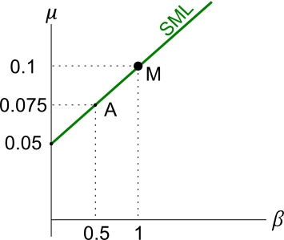 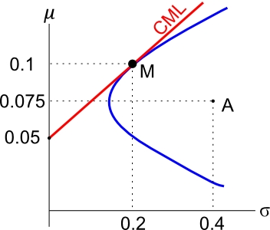

All fairly priced stocks or portfolios that plot on the CML must have zero idiosyncratic risk. They only have systematic risk.

***Calculation Example: the β- and***

***σ-graphs***

**Question:** Find stock A’s idiosyncratic standard deviation using the information in the below 2 graphs:

 

**Answer:**

$${σ_{total_{A}}}^{2}={β_{A}}^{2}.{σ_{M}}^{2}+{σ_{ε_{A}}}^{2}$$

$${0.4}^{2}={0.5}^{2}×{0.2}^{2}+{σ_{ε_{A}}}^{2}$$

${σ_{ε_{A}}}^{2}=$ 0.15

$σ_{ε_{A}}=$ 0.3873

So idiosyncratic variance is 0.15 units squared, and

idiosyncratic standard deviation is 0.3873 units.

**Question:** Find stock A’s systematic standard deviation.

**Answer:**

$${σ_{syst_{A}}}^{2}={β_{A}}^{2}.{σ_{M}}^{2}$$

$$={0.5}^{2}×{0.2}^{2}$$

$$=0.01$$

$$σ_{syst_{A}}=0.1$$

So systematic variance is 0.01 units squared, and

systematic standard deviation is 0.1 units.

Notice that idiosyncratic and systematic variances sum to 0.16 which is total variance, and the square root is 0.4 which is A’s total standard deviation.

Systematic plus idiosyncratic standard deviations don’t sum together to give total standard deviation since

$σ_{total_{i}}=\sqrt{{σ_{total_{i}}}^{2}}=\sqrt{{β_{i}}^{2}.{σ_{M}}^{2}+{σ_{ε_{i}}}^{2}}≠β_{i}.σ_{M}+σ_{ε_{i}}$

***Excess Returns: Jensen’s Alpha (α)***

If a stock is ‘fairly priced’ then the return on the stock is commensurate with its systematic risk ($β$). This means that the stock plots on the SML: $μ_{i CAPM}=r_{f}+β_{i}\left(μ_{M}-r_{f}\right)$

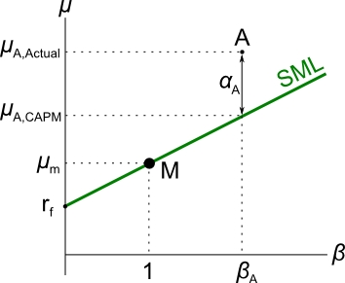But if markets are not efficient, some stocks may return more than they should for their level of systematic risk. This is called excess return or alpha ($α$).

The return on a mis-priced stock with an alpha can be calculated using:

$$μ_{i, actual}=r_{f}+β_{i}\left(μ_{M}-r_{f}\right)+α_{i}$$

$$μ_{i, actual}=μ_{i CAPM}+α_{i}$$

On the $β$-graph below, alpha is the vertical distance of the stock above the SML.

* 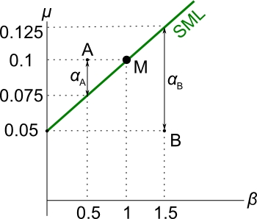If the alpha is **positive**, the stock returns more than it should and it will plot **above** the SML. Stock A has a positive alpha.
* If the alpha is **negative**, the stock returns less than it should and it will plot **below** the SML. Stock B has a negative alpha.

$$μ_{i CAPM}=r_{f}+β_{i}\left(μ_{M}-r_{f}\right)$$

$$μ_{i actual}=r_{f}+β_{i}\left(μ_{M}-r_{f}\right)+α_{i}$$

$$μ_{i actual}=μ_{i CAPM}+α_{i}$$

**Question**: Find the alphas of stock A and B ( $α_{A}$ and $α_{B}$).

**Answer**: From the diagram, $μ_{A}=0.1$ and $β_{A}=0.5$.

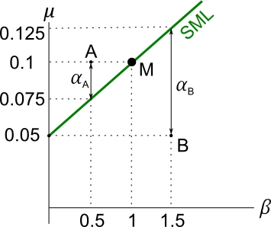 $μ_{i actual}=r_{f}+β_{i}\left(μ_{M}-r_{f}\right)+α_{i}$

$$0.1=0.05+0.5×\left(0.1-0.05\right)+α_{A}$$

$$α_{A}=0.025$$

For stock B,

$$μ_{i actual}=r_{f}+β_{i}\left(μ_{M}-r_{f}\right)+α_{i}$$

$$0.05=0.05+1.5×\left(0.1-0.05\right)+α_{B}$$

$$α_{B}=-0.075$$

***Arbitrage and Equilibrium Pricing: Why Excess Returns Should Not Persist***

**Question:**

* Stock A is expected to pay a constant dividend of $1 per share at the end of each year.
* For its level of systematic risk ($β_{A}$), it should have a return of 0.1 according to the CAPM.
* The stock is currently priced at $12.50.
* Find the alpha ($α_{A}$) of stock A now, and explain what should happen to the alpha and price ($P_{A}$) of stock A in the future.

**(Long-winded) Answer:**

Stock A’s required return according to the CAPM is 0.1. If it returned this much it would plot on the SML. So:

$$μ_{A CAPM}=0.1$$

But the current *actual* return on the stock is:

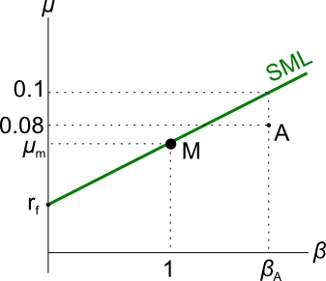 $μ_{A actual}=\frac{P_{1}-P_{0}+div_{1}}{P_{0}}$

$$=\frac{\$12.50-12.50+\$1}{\$12.50}$$

$$=0.08$$

By comparing the returns $μ_{A actual}$ and $μ_{A CAPM}$ it’s easy to see that the stock has an alpha of $-0.02$ which is ($0.08-0.1$).

For completeness:

$$μ_{A CAPM}=r_{f}+β_{A}\left(μ_{M}-r_{f}\right)$$

$$μ_{A actual}=μ_{A CAPM}+α_{A}$$

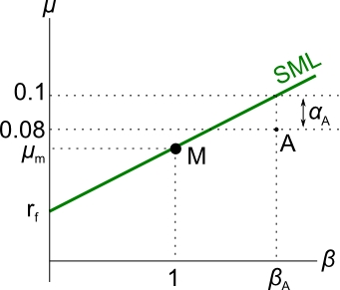 $μ_{A actual}=r_{f}+β_{A}\left(μ_{M}-r_{f}\right)+α_{A}$

$$0.08=0.1+α_{A}$$

$$α_{A}=-0.02$$

So stock A has a negative alpha, it returns less than it should. It plots below the SML. It is mis-priced.

In fact stock A is over-priced. The price should fall, which means the expected future return will increase, and the alpha will reach zero. This is why:

* Arbitrageurs will short the stock (by selling or short-selling) when they recognise the negative alpha. This is because no one wants to hold an asset that returns less than it should given its systematic risk.
* 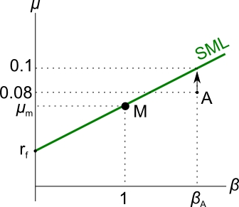Supply of stock A in the stock market will increase due to the heavy selling, forcing the stock price down.
* Since the price falls while the dividend remains constant, the dividend return will increase.

This can be seen from re-arranging the perpetuity formula, commonly known as the Dividend Discount Model (DDM), which says:

$P=\frac{dividend}{r}$ where the dividend is constant (g=0) so there's no expected capital growth.

Re-arranging, $r=\frac{dividend}{P}$

So as price $P$ falls, return $r$ increases.

* The actual return will continue to increase until it reaches the required rate of return according to the CAPM. So

$μ_{A actual}=μ_{A CAPM}=0.1$

After this happens, the:

* Alpha will be zero.
* Stock price will be $10 since:

$$P_{0}=\frac{dividend}{r}=\frac{\$1}{0.1}=\$10$$

Finally, to answer the question of “Find the alpha of stock A now, and explain what should happen to the alpha and price of stock A in the future”.

The alpha of stock A right now is -0.02, so it is over-priced.

The price should fall to $10, and then the alpha will be zero.

**Question**: If a stock with a constant dividend (no growth) has a positive alpha now, what should happen to its price now as well as its return and alpha in the future?

**Answer**: Arbitrageurs would buy the stock since its returns are attractive.

The increased demand for the stock will bid the price up ($↑P$).

This causes a short term positive historical capital return ($↑r_{cap, short term},$) in the past.

The expected dividend yield will be lower since the share price has risen but the dividend remains constant

$\left(↓μ_{div}=\frac{{dividend}_{1}}{↑P_{0}}\right)$.

This leads to a fall in the expected total return

($↓μ_{total}=μ_{cap}+↓μ_{div}$).

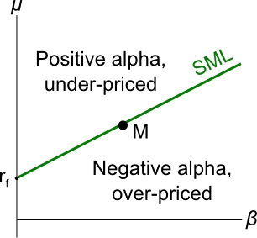This will occur until the expected total return reaches the CAPM's theoretical return. After this happens the alpha will be zero and the stock will be fairly priced.

Vice versa for overpriced stocks. Therefore all stocks should plot on the SML by this equilibrium pricing argument.

**Discussion**

What’s confusing in the previous example is that the price (and capital return) **rose**, yet the total expected return **fell**. How is this possible? If prices rose, shouldn’t returns be positive?

* The price rise causes a corresonding positive capital return is in the **past**, which is good!
* But the lower expected total return in the **future** is bad. Note that the expected future total return is not negative, just lower than what it was before.

Past historical returns and future expected returns are totally different.

The inverse relationship between price and expected returns is important in the bond market also: when fixed-coupon bond prices **rise**, yields to maturity **fall**.

***Modern Portfolio Theory – A Brief History***

**1950’s** - The foundations of modern portfolio theory were built by Harry Markowitz with his work on diversification and mean-variance efficiency.

**1960’s** – Sharpe, Lintner and Mossin extended Markowitz’s work in the form of the Capital Asset Pricing Model (CAPM). Interesting interview with Bill Sharpe: <http://web.stanford.edu/~wfsharpe/art/djam/djam.htm>

**1976** - Stephen Ross derived similar results to the CAPM in the more general Arbitrage Pricing Theory (APT). The APT requires only 3 assumptions compared to the many assumptions required in the CAPM.

***Putting the CAPM in Perspective***

So far we have actually been looking at the original Sharpe-Lintner-Mossin CAPM which is a single factor model that’s static since the betas are assumed to remain constant over time.

The CAPM’s only factor is the market risk premium $\left(r_{M}-r_{f}\right)$, where $r_{M}$ is a variable and $r_{f}$ is a constant.

Now that we’ve discussed some of the ideas and mathematics behind the CAPM, let’s look back at how the CAPM extends Markowitz’s Mean-Variance Framework.

***Drawbacks of the Markowitz Mean-Variance Approach***

1. Cannot be used to calculate the **price** or **expected return** of individual stocks. Only explains how to make an efficient *portfolio* with the minimum variance for a given return. Returns of the individual stocks are needed as inputs into the model.
2. For each new stock that is added to the model, the covariance of that stock with every other stock needs to be calculated.
3. Estimates of covariances are likely to change over time so sample estimates are likely to be unreliable.
4. No concept of systematic (undiversifiable or market) risk.

***Factor Pricing Models***

Factor pricing models simplify problem 2 by assuming that stocks are affected by common risk factors, such as returns on the market portfolio, GDP growth, and the unemployment rate for example.

When a stock is added to a factor model, only that stock’s covariance with each factor needs to be calculated. For the single factor CAPM, the covariance of the stock with the market portfolio M gives the numerator of the beta, and the denominator is just the market’s variance $\left(β_{i}= \frac{σ_{i,M}}{{σ_{M}}^{2}}\right)$.

The CAPM and APT are both factor models and there are single-factor and multi-factor versions of each.

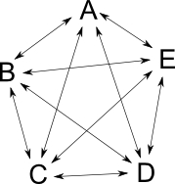***Covariances Between Stocks***

In Markowitz’s mean-variance framework, the covariance of each stock (A, B, C, D, E) with all others must be calculated.

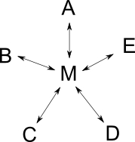But in a factor model such as the CAPM, only the covariance of each stock with M is needed. This implies that the only relationship between say A and B is through M. So if the CAPM is true, then residual returns should be independent of each other:

$cov\left(ε_{A},ε_{B}\right)=0$.

This not required in Markowitz's mean-variance approach.

***The CAPM***

* The single-factor version of the CAPM:
$$r_{i}=r_{f}+β_{i}\left(r_{M}-r_{f}\right)+ε_{i}$$

* The only factor is the market risk premium $\left(r_{M}-r_{f}\right)$, where $r_{M}$ is a variable and $r_{f}$ is a constant.
* Assumes that stock returns are only determined by changes in the market return $r_{M}$ and random firm-specific changes in the residual return $ε_{i}$.
* Therefore the only relationship between the returns of two stocks A and B is through changes in the market rate of return $r_{M}$, so the stocks’ residual returns should be independent: $cov\left(ε_{A},ε_{B}\right)=0$

***CAPM Formulas***

$r_{i}=r_{f}+β_{i}\left(r_{M}-r_{f}\right)+ε_{i}$ and $μ_{i}=r_{f}+β_{i}\left(μ_{M}-r_{f}\right)$

$$cov\left(ε_{A},ε_{B}\right)=0$$

$$β_{i}=\frac{σ_{i,M}}{{σ_{M}}^{2}}$$

From the above, the following equations can be derived:

$${σ_{i,total}}^{2}={β_{i}}^{2}.{σ_{M}}^{2}+{σ_{i,ε}}^{2}$$

$$σ_{1,2}=β_{1}.β_{2}.{σ_{M}}^{2}$$

$$β_{P}=x_{1}β_{1}+x_{2}β_{2}+…+x_{n}β_{n}$$

***The Cost of Equity ($r_{e}$)***

The cost of equity ($r_{e}$) is the total rate of return that equity holders deserve for their level of risk. It has many names including the required return on equity, shareholders' cost of capital, and stock-holder's required return.

There are two methods to find the cost of equity.

We can use the Dividend Discount Model (DDM):

$$r_{e}=\frac{C_{1}}{P_{0}}+g$$

or the Capital Asset Pricing Model (CAPM):

$$r_{e}=r_{f}+B_{e}\left(r_{m}-r_{f}\right)$$

***DDM to find the Cost of Equity***

We can find the cost of equity using the Dividend Discount Model, also known as Gordon's Growth Model or the perpetuity with growth formula,

$$P_{0}=\frac{C_{1}}{r_{e}-g}$$

$C_{1}=$ cash flow received at $t=1$. The cash flows go on forever, but grow by $g$ every period. For stocks, the cash flow is the dividend.

$g=$ effective growth rate of the dividend $C_{1}$ per period. It is also the capital return (price increase) of the stock.

$r_{e}=$ effective cost of equity over a single period. It is the total return of the stock.

After re-arranging the equation to make $r_{e}$ the subject, we get:

$$r_{e}=\frac{C_{1}}{P_{0}}+g$$

Note that this is the familiar formula that separates total return into its income and capital components, but applied to an equity security (a stock or share).

$$r_{total}=r_{ income}+r_{capital}$$

This makes sense since g is the capital return and $\frac{C_{1}}{P_{0}}$ is the dividend yield which is a stock's form of income return.

***CAPM (or SML) to find the Cost of Equity***

$$r_{e}=r_{f}+B_{e}\left(r_{m}-r_{f}\right)$$

Where:

$r_{e}=$ effective total return of the stock 'e'.

$B_{e}=$ beta of the stock 'e'. The beta is a measure of systematic risk, defined as $B_{e}=\frac{cov\left(r_{e}, r_{m}\right)}{var\left(r_{m}\right)}$.

$r_{f}=$ effective total return of the risk free asset (government treasury bonds).

$r_{m}=$ effective total return of the market portfolio (stock index for example the ASX200 (Australia) or S&P500 (US)).



This method of finding the cost of equity is also called the SML (Security Market Line) method.

This is because we are finding $r_{e}$ on the SML using the stock's beta $B_{e}$.

***Calculation Example: Cost of Equity***

**Question:** Find the firm's cost of equity using:

(i) the DDM and

(ii) the CAPM or SML

with the information below:

The firm's stock price is $20,

Beta of equity is 1.5,

Market return is 10% p.a.,

Treasury bonds yield 5% p.a.,

The stock will pay its next annual dividend of $2.50 in one year, which grows at a rate of 2% p.a.. All rates are effective pa.

**Answer:**

(i) Using the Dividend Discount Model (DDM):



$$r_{e,DDM}=\frac{D_{1}}{P_{0}}+g$$

$=\frac{2.50}{20}+0.02 =0.145$

(ii) Using the Capital Asset Pricing Model (CAPM):

$$r_{e,CAPM}=r_{f}+B_{e}\left(r_{M}-r_{f}\right)$$

$$=0.05+1.5×\left(0.1-0.05\right)$$

$$=0.125$$

In theory, they should both be the same. They are only different because our input numbers are inaccurate, and/or because the assumptions of the models are violated.

For example, the DDM assumes dividends grow forever at a constant rate which is obviously not going to happen in reality. The (static) CAPM assumes that the beta doesn't change which is also silly.

In practice, an arbitrary weighted average of the two might be used, weighted according to which one you think is more accurate and suitable for the project being valued.

***The Cost of Debt ($r_{d}$)***

The cost of debt is also known as the required return on debt, debt-holders' cost of capital, debt-holder's required return, or total return on debt.

The cost of debt ($r_{d}$) can also be found using two methods: discounted cash flows (DCF) or the CAPM.

But since the cash flows from debt are more predictable than shares, most practitioners prefer to use the DCF method. This is done using the fixed coupon bond-pricing equation.

$${Price}_{\begin{aligned}fixed \\ coupon \\ bond\end{aligned}}=PV\left(annuity of coupons\right)+PV\left(principal\right)$$

$$=\frac{C_{1}}{r_{eff}}\left(1-\frac{1}{{\left(1+r_{eff}\right)}^{T}}\right) + \frac{{Face}_{T}}{{\left(1+r_{eff}\right)}^{T}}$$

The bond price, coupon rate and face value are known so the yield (r) can be computed, but often the calculation requires trial and error or a financial calculator or spreadsheet with the solver function. The exception is the more simple zero-coupon bonds whose yields can easily be found using basic algebra and an ordinary calculator.

Note that when the promised coupons $(C_{1}, C_{2},…, C_{T})$ and face value $({Face}_{T})$ are used in the above equation to find the bond yield ($r_{eff}$), this will actually give the ‘promised yield’ which is higher than the actual expected yield since the bond issuer may go bankrupt. This credit or default risk means they will not always pay back the coupon and principal payments they promise.

***Expected returns and probabilities***

Probabilities represent the chance of something happening. Some useful rules:

* The sum of the probabilities of all possible outcomes is always 1 (=100%).
* ‘Or’ means sum the probabilities.
* ‘And’ means multiply the probabilities.

**Question:** At university you can pass or fail a subject. If the probability of failing is 10%, what is the chance of passing the subject?

**Answer:** You can pass ***or*** fail, and the ‘or’ means add the probabilities. The sum of the probabilities of the complete set of outcomes is always one, so the probability of failing or passing must be one. Let the probability of passing be $p_{pass}$ and the probability of failing be $p_{fail}$.

$$p_{pass}+p_{fail}=1$$

$$p_{pass}+0.1=1$$

$$p_{pass}=1-0.1=0.9$$

So there’s a 90% chance of passing a single subject.

**Question:** In a 3 year university degree with 4 subjects per semester and 2 semesters per year, a student will complete 24 (=3*2*4) subjects. If the chance of failing a single subject is 10%, what is the chance of passing every single subject? Assume that you have average ability and motivation.

**Answer:** Passing every subject means that you must pass the first one and the second and the third and so on. Since it’s ‘and’, the probabilities must be multiplied. The chance of passing a single subject is 90%. So the chance of passing all 24 subjects is:

$$p_{pass all 24 subjects }=p_{pass, 1}×p_{pass, 2}×…×p_{pass,24}$$

$$=0.9×0.9×…×0.9={0.9}^{24}$$

$$=0.079766443≈8\%$$

***Expected returns, uncertainty and probabilities***

The expected return of an asset when there are different possible states of the world (good, ok, bad, and so on) is the sum of the return in each state of the world multiplied by the probability.

***Calculation example***

**Question:** Find the expected return on the stock market given the below information about stocks’ returns in different possible states of the economy.

|  |  |  |
| --- | --- | --- |
| **Stock Returns in Different**  **States of the Economy** | | |
| **State of economy** | **Probability** | **Return** |
| Boom | 0.3 | 0.6 |
| Normal | 0.5 | 0.1 |
| Bust | 0.2 | -0.5 |
|  |  |  |

**Answer:** the expected return ‘E(r)’ or $μ$ is equal to:

$$E(r)=p_{1}.r_{1}+p_{2}.r_{2}+…+p_{1}.r_{1}$$

$$=0.3×0.6+0.5×0.1+0.2×-0.5$$

$$=0.13=13\%$$